4CS015
Fundamentals of Computing
Workshop: Week 10
Linux_File

Name: -Rohit Sahani
Student Id: -NP02CS4A250027

- Create the directory BIC in the desktop.
- Write the command to print current working directory. List the files and directories in the current working directories. Insert the image of your terminal here.

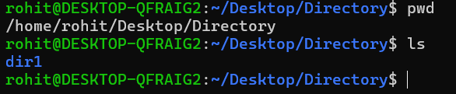

- Create New.txt file containing text “Biratnagar International College”, in the BIC directory.

- Delete New.txt file from BIC directory.

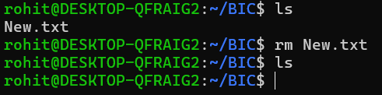

- Remove directory BIC from the Desktop.

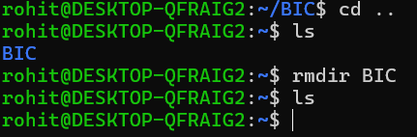

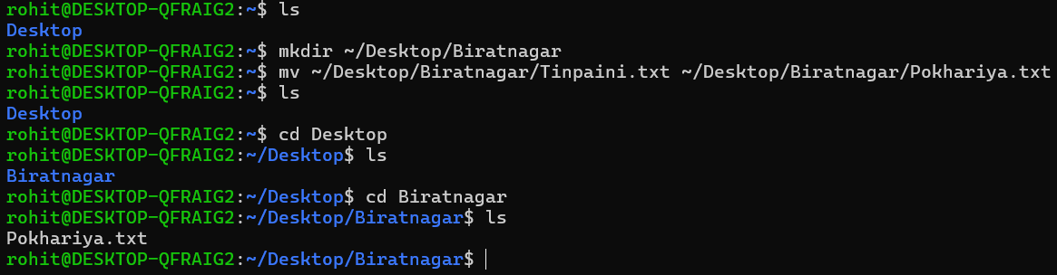
- Create directory Biratnagar in the desktop containing file Tinpaini.txt, Rename Tinpaini.txt as Pokhariya.txt

- Create Directory Ithari in the Desktop and move Pokhariya.txt of directory Biratnagar in directory Ithari.

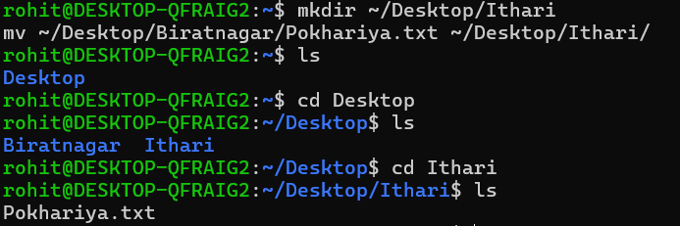

- What is the command to list all the invisible files and to display the directories in detail?
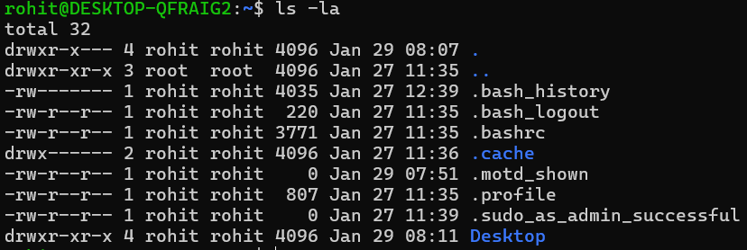

- Create file bic.txt containing text “Biratnagar International College, Biratnagar” and another file iic.txt containing text “Ithari International college, Ithari” concatenate these two files and give name BIC.txt.
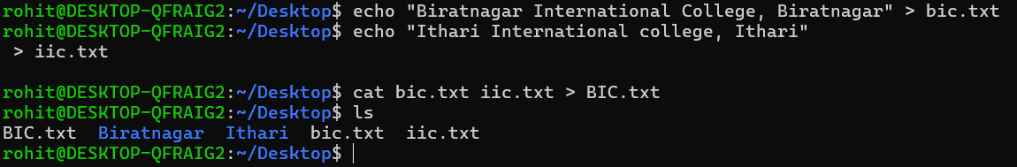

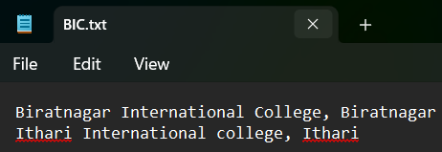
- Create filename1.txt and filename2.txt in the Desktop and create compressed file new.zip which contains filename1.txt and filename2.txt.
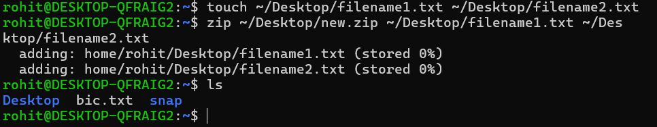

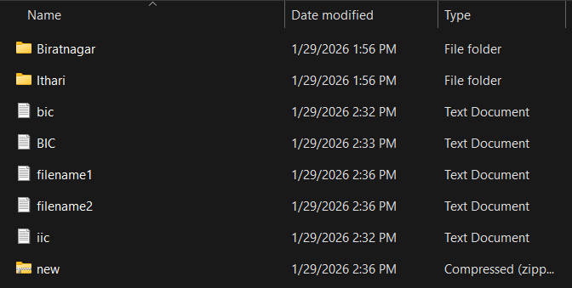

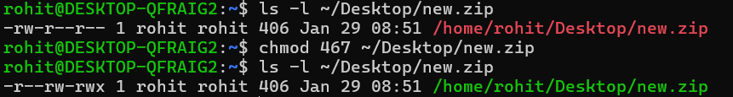
- Check the permissions for User, group and world for new.zip and set read permission for user, read and write permission for group and read write and execute permission for world.

- Write the command to check your last 10 commands.

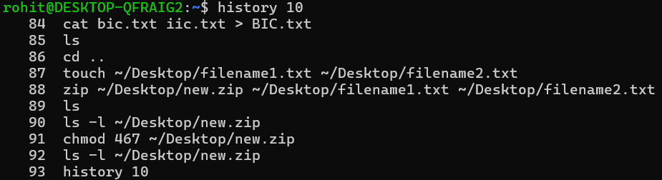

- Write the command to check current user.

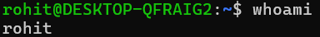
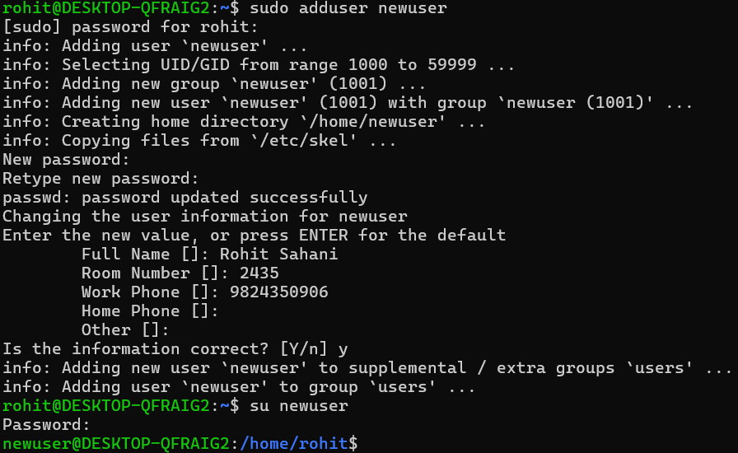
- Write the command to add user having user name newuser and switch to newuser.

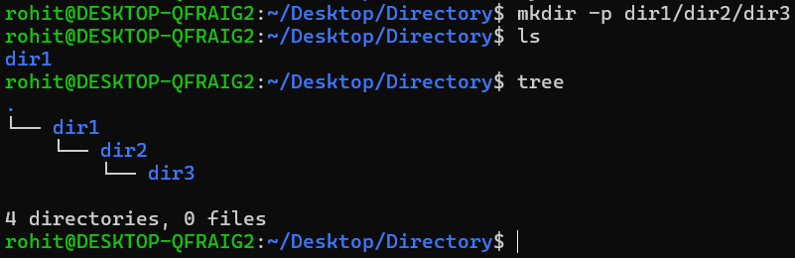
- Create the following directories in and paste your result here.

